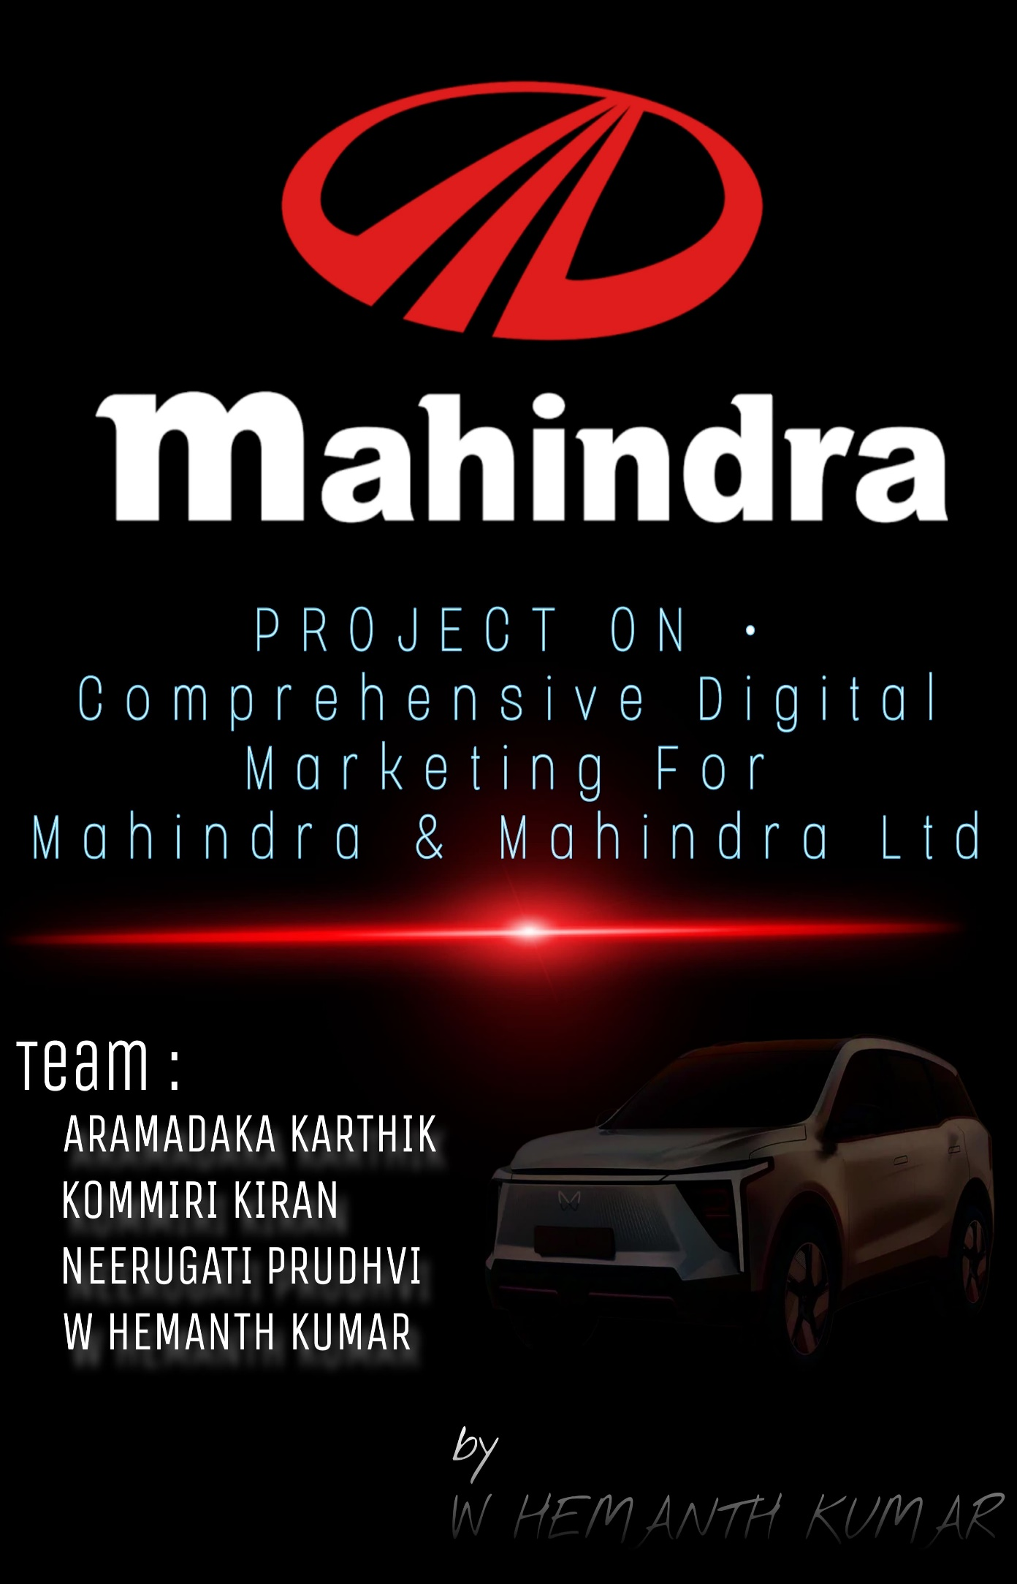

Comprehensive Digital Marketing for Mahindra & Mahindra Ltd

**1 .Brand Study, Competitor analysis & Buyer's/Audience's Persona**

1.1_RESEARCH BRAND IDENTITY

A. Mission/ Values:

*Mahindra & Mahindra Mission Statement:*

We’ve made humanity’s innate desire to Raise our driving process: we will challenge conventional thinking and innovatively use all our resources to drive positive change in the lives of our stakeholders and communities across the world, to enable them to Rise. Our purpose is why we exist and why we come to work every day, infusing our lives with meaning, and galvanizing us to deliver our promise.

*Mahindra & Mahindra Vision Statement:*

Committed to investing in technology, growing our global presence and maintaining our leadership position

*Mahindra & Mahindra Values:*

=Focus

=Customer First

=Professionalism

B. UPS

Mahindra & Mahindra's Unique Selling Propositions (USPs) are:

1. Rugged & Versatile SUVs: Vehicles such as the “Thar” and “Scorpio” are famous for off-road performance and ruggedness, targeting adventure enthusiasts and rural markets.

2. Indian Market Focus: Vehicles such as the “Bolero” and “Pik-Up” are designed to suit India's rural and semi-urban requirements, and **Mahindra Tractors** for farmers.

3. Leadership in Electric Mobility: Mahindra Electric provides affordable EVs such as the”e2o Plus” and “eVerito”, and is aimed at increasing electric offerings.

4. Sustainability: The ‘"Rise" philosophy’ focuses on green products, such as energy-efficient farming solutions and electric vehicles.

5. Commercial Vehicles: Mahindra dominates the small commercial vehicle segment with products such as the “Bolero Pik-Up”.

6. Value-for-Money Pricing: Provides value-for-money cars with robust features, like the “Thar” and “Bolero”, to attract price-sensitive customers.

7. Extensive After-Sales Service: An extensive service network provides strong customer support and peace of mind.

8. Strong Brand Equity: Renowned for tough reliability, Mahindra has established a strong, dependable brand reputation.

9. Innovation & Technology: Provides sophisticated features like ‘’ADAS’’ in cars like the XUV700

10. Global Presence: Growing internationally, particularly in the “tractor” and “electric vehicle** sectors, with success in markets such as the U.S., South Africa, and Europe.

These USPs render Mahindra a well-known and reliable brand in India and overseas markets as well.

C. Brand Message: Mahindra & Mahindra's brand message centers around the philosophy of **"Rise"**, symbolizing **empowerment**, **progress**, and **positive change**. It highlights the brand's focus on **ruggedness**, **dependability**, and **innovation**, especially through products like the **Thar** and **XUV700**, designed to help customers **overcome challenges** and pursue their ambitions.

D. Brand Tag Line: Mahindra & Mahindra's brand tagline is **"Rise"**. This tagline reflects the company’s commitment to **empowerment**, **innovation**, and **progress**, encouraging individuals and communities to overcome challenges and achieve their ambitions. It embodies the spirit of positive change and growth, both for customers and society as a whole.

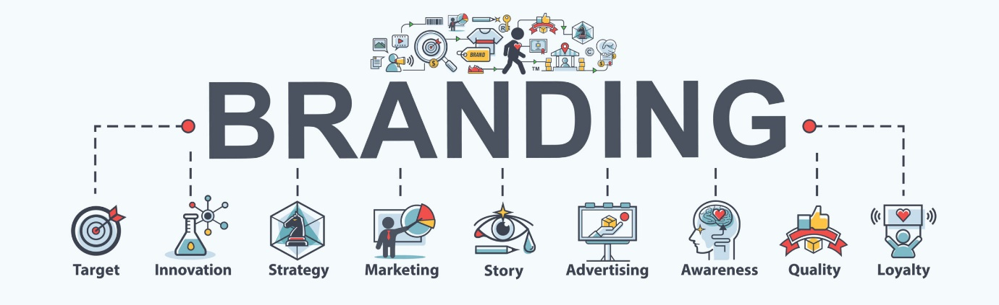

1.2 Competitor analysis

To conduct a competitor analysis for **Mahindra & Mahindra** (a leading Indian multinational company, operating in various sectors such as automotive, agriculture, IT, and more), let's focus on **three competitors** within the **automotive** sector. The selected competitors will be:

• Tata Motors

• Maruti Suzuki

• Hero MotoCorp

Competitor 1: ->Tata Motors

Tata Motors is a prominent player in the Indian automobile sector and also has a global presence with a range of passenger and commercial vehicles.

Unique Selling Propositions (USPs):

Innovative Technology: Tata Motors has a reputation for incorporating the latest technology in their cars, with a focus on sustainability (e.g., electric cars such as the Tata Nexon EV).

Affordability and Value for Money: Competitive urban and rural price points for both make their products more affordable to a wider base.

Sustainability and Green Vehicles: The Company is the leader in the electric vehicle (EV) business in India, providing green solutions appealing to ecologically aware customers.

Online Communication

Website & Social Media: Tata Motors website focuses on the company's intention to be an innovative, technology-driven, and sustainable organization. They frequently make their EV offerings and green initiatives known through Twitter, Facebook, and Instagram social media.

Branding Focus: Their communication aim is to portray themselves as a "sustainable" brand that offers cutting-edge technology at accessible prices. Tata Motors frequently adopts storytelling to develop an emotional bond with customers and emphasize how their vehicles contribute towards enhancing lives.

Competitor 2: Maruti Suzuki  
Maruti Suzuki dominates India's passenger vehicle market and boasts an enormous customer base based on its reliability and affordability reputation.  
 Unique Selling Propositions (USPs):  
Affordability & Fuel Efficiency: Maruti Suzuki vehicles are fuel-efficient, reliable, and affordable, hence favoured for first-time automobile owners.  
Strong After-Sales Service Network: The Company boasts a wide service and spare parts network all over India, which contributes to its reliability.  
Wide Range of Models: From small cars such as the Alto to high-end cars such as the Vitara Brezza, Maruti Suzuki has a wide range of vehicles serving different market segments.  
 Online Communication:  
Website & Social Media: Maruti Suzuki attempts to connect customers with tools supporting them during the buying process, including car configurators on websites and virtual showrooms. The social media is frequently used for customer satisfaction drives, road safety initiatives, and product launches.  
Branding Focus: Customer initiatives, ruggedness, and value-for-money value are usually portrayed in their website presence. Trust in the trustworthiness of their cars is established using testimonials from customers as well as through online reviews.

Competitor 3: Hero MotoCorp  
Hero MotoCorp is India's largest motorcycle maker and is also growing internationally.  
  
 Unique Selling Propositions (USPs):  
Innovative Design & Technology: Hero MotoCorp is renowned for its innovative design strategy for motorcycles and scooters. Their products are positioned to be mileage-high, performance-high, and affordable, especially in the rural and semi-urban segments.  
Strong Brand Loyalty & Heritage: Hero has established a strong brand identity through regular product quality and value. It holds a large market share, particularly in the commuter segment.  
Global Expansion: Hero MotoCorp is focusing on enhancing its presence in international markets such as Latin America and Africa.

Online Communication  
Website & Social Media: Hero's digital communication highlights its history and technological focus. They leverage social media to interact with their audience by means of promotions, sponsorships, and influencer collaborations. They also emphasize their social responsibility initiatives and environmental stewardship.  
Brand Focus: The brand is communicating how it is committed to making "mobility" available and reliable, especially to people in the commuter segment. Hero also employs interactive content such as videos, blogs, and feedback to engage the younger generation.

1.3 Buyers/Audience Persona

Name: Empowered Professional/Family Leader  
  
Demographics:  
  
- Age: 30-55 years  
- Gender: Male-dominated, but also speaks to females  
- Location: Rural, semi-urban, and urban settings  
- Occupation: Professionals, business owners, farmers, agri-business entrepreneurs  
- Income Level: Middle to high-income levels  
- Education: College-educated, with professional or technical degrees.  
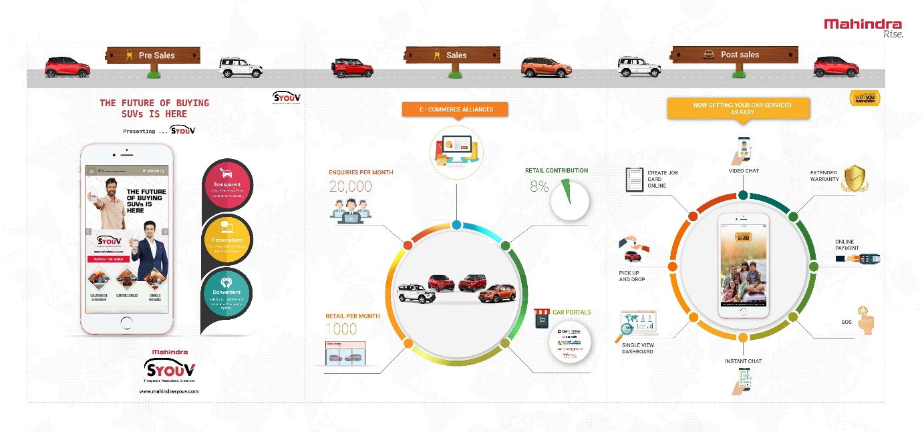  
Psychographics:  
  
- Values: Reliable, durable, and community-focused; rural consumers prefer tradition, while urban consumers welcome tech and innovation.  
- Interests: Outdoor recreation, family vacations (Thar), agriculture (Tractors), technology (electric cars), and contemporary agriculture solutions.  
- Lifestyle: Blend of contemporary convenience with traditional values; urban buyers desire luxury and performance, rural purchasers emphasize utility and value.  
  
- Purchase Motivations: Reliability, faith in the Mahindra brand, value for money, and innovative products (e.g., electric cars, smart farming technology).  
- Channels: Online search (urban), offline outlets (rural), and digital channels for customer service.  
  
Challenges:  
  
- Rural Market: Insufficient after-sales service in far-flung areas, requirement of low-cost financing.  
- Urban Market: Competition with high-end international brands in the automobile industry.  
  
Objectives:  
  
- Rural Customers: Become more productive and prosperous with Mahindra farm machinery and trucks.  
- Urban Customers: Lead an adventurous but family-oriented life, while embracing innovative, green technology (e.g., electric cars).  
  
Marketing Focus:  
  
- Tone & Voice: Reliable, tough, community-oriented, and technologically advanced.  
- Key Messages: "Built for Tough Conditions," "Innovative Solutions for Modern India," "Driven by Purpose."  
  
_____  
This character emphasizes Mahindra's large target market, ranging from rural farmers to city business professionals, stressing reliability, innovation, and community values.

**2. SEO & Keyword Research**

A Mahindra & Mahindra SEO Audit is an in-depth review of the company website to determine strengths, weaknesses, and areas of improvement to maximize its online presence. Below is a sample outline of an SEO audit for Mahindra & Mahindra:

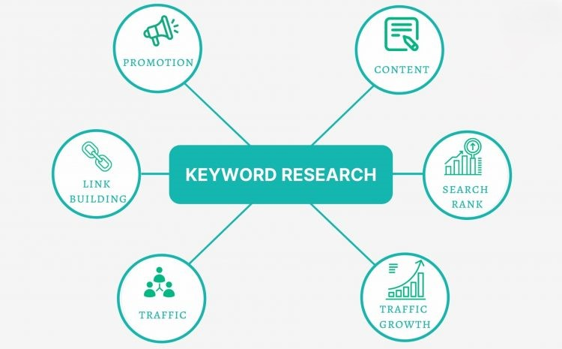

2.1 SEO Audit

1. Technical SEO:  
 Site Speed: Make sure to have quick loading with tools such as Google PageSpeed Insights.  
 Mobile Optimization: Verify mobile-friendliness with Google's Mobile-Friendly Test.  
 Indexing & Crawlability: Make sure the site is crawlable and well-indexed through Google Search Console.  
 Sitemap & Robots.txt: Ensure XML sitemap and robots.txt are well-indexed.  
2. On-Page SEO:  
 Keyword Optimization: Make sure to use keywords in titles, headers, and content (e.g., "Mahindra XUV700 review").  
 Content Quality: Develop unique, compelling content for product pages and blogs.  
 Internal Linking: Improve site structure by linking similar products (e.g., linking "Mahindra tractors" to "Mahindra farming").  
 Image Optimization: Optimize images and include alt text with targeted keywords.  
3. Off-Page SEO:  
 Backlink Profile: Develop quality backlinks from industry blogs and news websites.  
 Local SEO: Optimize for local search with Google My Business listings.  
 Social Media Presence: Expand social media involvement by posting product news and posts.  
4. User Experience (UX) & Content:  
 Navigation: Make the site easy to navigate and navigation clear (e.g., CTAs such as "Book a Test Drive").  
 Engagement Metrics: Set out to drive bounce rate and time on site through engaging content.  
 Conversion Optimization: Enhance lead generation by optimizing landing pages and CTAs.  
5. Competitor Analysis:  
 Competitor Monitoring: Map competitors' SEO plans for gaps in keywords and backlink targets.  
Conclusion  
 Action Items: Enhance technical SEO, content optimization with focused keywords, backlink building, and UX improvement to boost visibility and engagement.

2.2 Keyword Research

Mahindra & Mahindra SEO & Keyword Strategy:

1. Keyword Research:  
Automotive: Brand-specific keywords like "Mahindra XUV700," "Mahindra Thar price," and general keywords like "best SUVs in India" and "off-road vehicles."  
Agriculture: Keywords like "Mahindra tractor price," "best tractors in India," and long-tail keywords like "Mahindra tractors for small farms."  
Electric Vehicles (EV): Keywords like "Mahindra electric vehicle range," "Mahindra e2o Plus," and "best electric cars in India."

2. SEO Strategies:  
On-Page: Optimize the content using relevant keywords in title, headers, and Meta descriptions. Prioritize product pages, blogs, and FAQs.  
Off-Page: Obtain backlinks from authoritative sources, optimize for local SEO, and post engaging content on social media platforms.  
Technical SEO: Ensure page loading speed is fast, apply schema markup, and submit XML sitemaps for correct indexing.

3. Performance Monitoring:  
Monitor keyword performance and traffic via Google Search Console and Google Analytics, and track conversions for strategy optimization.  
This strategy will enhance Mahindra & Mahindra's visibility, reaching out to target audiences within automotive, agriculture, and EV spaces.

2.3 On-page optimization

For Mahindra & Mahindra Ltd., here is a brief Meta Tag Optimization and Content Optimization strategy:  
  
1. Meta Tag Optimization:  
Title Tags: Provide unique and keyword-dense titles for every page (less than 60 characters).  
  
Example: "Mahindra XUV700 – Luxury SUV | Mahindra & Mahindra"  
Meta Descriptions: Craft engaging descriptions (150-160 characters) with keywords.  
  
Example: "Discover the Mahindra XUV700 SUV with luxury and performance. Get pricing, features, and more."  
Header Tags (H1, H2, H3): Employ headers with keyword-relevant content for proper structure.  
  
Example: H1: "Mahindra XUV700 - The Future of SUVs."  
Image Alt Text: Include descriptive alt text on images with keywords.  
  
Example: "Mahindra XUV700 front view."

2. Content Optimization:  
Keyword Research: Employ relevant keywords (primary and long-tail) on product pages and blogs.  
  
~Content Structure: Develop engaging, informative content with emphasis on user needs (e.g., SUV specs, farming benefits).  
  
~Keyword Integration: Incorporate keywords organically in title, headings, and body copy.  
~Internal Linking: Interlink related products or pages to enhance navigation and SEO.  
~Mobile Optimization: Keep content mobile-friendly with short paragraphs and bullet points.  
~Engagement: Make CTAs clear like "Book a Test Drive" or "Learn More" to enhance conversions.

**3. Content Ideas and Marketing Strategies**

Mahindra & Mahindra Ltd. is a renowned brand in India and worldwide, especially in industries such as automobiles, agriculture, construction, and aviation. Their marketing strategies and content concepts are diverse and strategic to ensure their leadership and engagement in various markets. Some of the content concepts and marketing strategies that Mahindra & Mahindra may use are as follows:

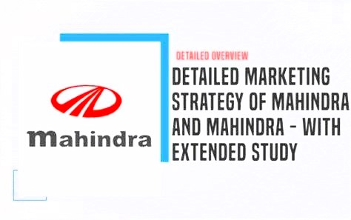  
  
3.1. Content Ideas  
a. Product-Focused Content  
 ~Feature Stories: Highlight technology and innovations in Mahindra vehicles and equipment.  
 ~Customer Success Stories: Highlight real-life experiences of customers gaining from Mahindra products.  
 ~Behind-the-Scenes: Highlight the manufacturing and design process.  
b. Sustainability & CSR Content  
 ~Sustainability Initiatives: Highlight electric vehicles (EVs) and green solutions.  
 ~Mahindra Rise Campaign: Highlight social impact through rural development and empowerment.  
c. Educational Content  
 ~How-To Guides: Tips on maintaining Mahindra vehicles and optimizing performance.  
 ~Industry Insights: Thought leadership in mobility and agricultural technology.

Community-Driven Content  
 ~User-Generated Content: Invite Mahindra owners to post their experiences on social media.  
 ~Surveys and Polls: Gather customer feedback for insights and present them interactively.  
3.2. Marketing Strategies  
a. Customer-Centric Approach  
 ~Personalization: Customize marketing messages across various customer segments.  
 ~Loyalty Programs: Provide rewards and benefits to loyal customers.  
b. Digital Marketing  
 ~Social Media Campaigns: Reach out to customers through targeted advertising and influencer collaborations.  
 ~Interactive Online Experiences: Utilize AR/VR for product discovery and virtual showrooms.  
c. Brand Storytelling  
 ~Mahindra Rise: Establish the brand as a catalyst for communities and innovation.  
 ~Durability Focus: Emphasize the strength and dependability of Mahindra products.  
d. Sustainability and EV Focus  
 ~EV Promotion: Promote awareness of Mahindra's electric vehicles.  
 ~Green Certifications: Highlight sustainability efforts in manufacturing and products.

e. Regional Marketing  
Rural and Urban Targeting: Engage rural and urban customers equally well through local media and online campaigns.  
With these content ideas and marketing approaches, Mahindra can fortify its brand presence and reach a broader audience.

**4. Content Creation and Curation for Mahindra & Mahindra Ltd.**The project includes various aspects of digital content creation, design, video editing, social media marketing, and email campaigns. What follows is a summary of how Mahindra & Mahindra Ltd. can create, curate, and implement content effectively to improve its brand visibility.  
  
4.1. Post Creations  
a. Social Media Posts  
 ~Product Highlights: Emphasis on Mahindra vehicle and machinery features, performance, and benefits (e.g., SUVs such as Thar, tractors, EVs).

~User-Generated Content (UGC): Post content form Mahindra customers or enthusiasts, describing their experience with Mahindra products.

~Sustainability Posts: Highlight Mahindra's initiatives such as electric vehicles (e.g., e2o Plus), green production, and CSR efforts.  
 ~Event Announcements: Publicize upcoming events, including new vehicle releases, expos, or online webinars.  
b. Content Calendar  
Schedule posts in line with major product releases, festivals, and seasonal promotions in order to maintain the content in line with customer interest.  
Example Post Types:  
"Did You Know?" series: Interesting facts regarding Mahindra products, e.g., an interesting feature of the Mahindra Thar.  
 ~Customer Testimonial Posts: Post quotes and pics/videos of satisfied customers.  
4.2. Designs/Video Editing  
a. Design Ideas  
 ~Infographics: Highlight the main product features, comparison tables, and customer satisfaction figures.  
 ~Carousel Posts: Employ carousels on Facebook or Instagram to showcase Mahindra product lines, customer testimonials, or feature highlights in a step-by-step and compelling way.  
 ~Animated GIFs: Design short, attention-grabbing animated GIFs for social media, demonstrating Mahindra vehicles moving or emphasizing innovative aspects.  
b. Video Editing  
 ~Product Demos: Produce brief, snappy videos showing how Mahindra products work or featuring certain attributes (e.g., toughness of the Thar or user-friendliness of Mahindra tractors).  
 ~Behind-the-Scenes Videos: Highlight the production process or the construction of Mahindra cars, emphasizing craftsmanship, technology, and environmental protection initiatives.  
 ~Customer Testimonials: Gather customer-created video testimonials and edit them together into an influential testimonial video for use on social media or YouTube.  
c. Tools  
 ~Design Tools: Canva, Adobe Spark for post and graphic creation.  
 ~Video Editing Tools: Adobe Premiere Pro, Final Cut Pro, or InShot to create quality video content.  
4.3. Ad Campaigns Over Social Media  
a. Social Media Platforms  
 ~Facebook & Instagram Ads: Utilize these sites for organic and paid advertising to specific audiences (e.g., rural buyers for tractors or urban buyers for SUVs and EVs).  
 ~YouTube Campaigns: Execute video ads highlighting Mahindra vehicles, product capabilities, and customer testimonials.  
 ~LinkedIn Ads: Drive Mahindra's thought leadership, farming innovations, and company sustainability efforts.  
b. Campaign Types  
Seasonal/Promotional Campaigns: Design temporary offers or special discounts on Mahindra products (e.g., "Summer Sale on Mahindra SUVs").  
 ~Product Launches: During a new model launch, design a focused campaign with teaser videos, countdowns, and sneak peeks.  
 ~EV Awareness: Highlight Mahindra's electric vehicals as sustainable and the modility of the future

c. Targeting & Retargeting  
 Utilize Facebook and Instagram's advanced targeting features to target audiences based on interests, behaviors, and demographics, and even previous interaction with Mahindra content.  
 ~Retargeting: Target users who have visited the Mahindra site or engaged with previous posts but haven't purchased yet.  
4.4. Email Ideation and Creation  
a. Email Campaign Types  
 Product Launch Emails: Launch new Mahindra models or equipment with good-quality images, main features, and a prominent call-to-action (CTA) to schedule a test drive or visit a showroom.  
 Newsletter: Periodic updates on Mahindra products, customer testimonials, future events, and environmental initiatives.  
 ~Seasonal Offers: Promote discounts, financing, or festive promotions, particularly during major sales seasons (e.g., Diwali, New Year).  
b. Email Design  
 Clean, Responsive Design: Make emails look fantastic on desktop and mobile platforms, with rich visuals, brief product descriptions, and prominent CTAs (e.g., "Book a Test Drive," "Shop Now," "Learn More").  
 ~Personalized Content: Employ customer segmentation to send them personalized emails (e.g., tractor purchasers receive tractor content, SUV fans receive SUV news).  
c. Email Tools  
 ~Email Marketing Platforms: Utilize tools such as Mailchimp, HubSpot, or Constant Contact for email list management, design of visually engaging emails, and analytics.  
 ~A/B Testing: Test subject lines, visuals, and CTAs to enhance open rates and conversion rates.  
Implementation Timeline  
Week 1-2:  
  
Develop and design social media content calendar.  
Develop first posts and ad creatives.  
Edit product demo videos and design animations/GIFs.  
Week 3-4:  
  
Rollout ad campaigns across social media platforms, product awareness focus.  
Begin email campaign for product launch or seasonal promotion.  
Track campaign performance and optimize from analytics (engagement, clicks, conversions).  
  
Ongoing:  
  
Keep social media active with user-generated content.  
Regularly post to email subscribers with new content and promotions.  
Post weekly content (testimonials, features, behind-the-scenes).  
Conclusion  
Through emphasizing content engagement and focused campaigns, Mahindra & Mahindra Ltd. can strengthen its digital presence. Developing varied content like social media updates, email marketing, and video content, along with well-thought-out ad plans, will facilitate brand awareness, customer engagement, and effective sales.

***Conclusion***

Mahindra & Mahindra Ltd. boasts a robust, diversified brand presence across the auto, agricultural, and electric mobility space. Having linked their mission of "Rise" with strong offerings across rugged autos, new-age electric mobility, and farm solutions, Mahindra has been able to position itself as a reliable brand name in India and the world.  
  
With an in-depth grasp of the brand identity, differentiated selling propositions, and audience persona, Mahindra is well-placed to serve a variety of customer requirements, ranging from rural farmers to urban professionals. This strategic convergence with customer requirements allows Mahindra to retain its market leadership while seeking expansion in new and emerging areas, especially electric mobility and sustainability.  
  
For SEO and digital marketing, the proposed audit and keyword strategy for Mahindra lay a great foundation to optimize its online presence. From site speed improvements and mobile optimization to content development and on-page SEO, there are vast opportunities to improve visibility, user engagement, and conversions. Competitor profiling with Tata Motors, Maruti Suzuki, and Hero MotoCorp identifies major areas where Mahindra can create a difference and capitalize on its distinctive strengths like ruggedness, innovation, and after-sales.  
  
Content marketing, as exemplified through customer testimonials, educational manuals, green initiatives, and localised marketing campaigns, will support the values of reliability, community, and progress. Social media usage, advertising efforts, and emails will further uphold Mahindra's engagement with its diverse people, making sure the brand keeps its relevance, interest, and visibility.  
  
Overall, through ongoing evolution of its online strategies and commitment to customer-relevant content, Mahindra & Mahindra Ltd. is poised to continue its dominance in different markets while building a solid and long-term relationship with customers. Having a well-defined digital marketing strategy, Mahindra can go on to excel, address customers' needs, and lead by innovation and empowerment.